  - SUBJECTS AND METHODS

This study was carried out on 240 normal Egyptian individuals of both sexes.
Regarding the individuals, subjects were randomly chosen from those coming to Sama Scan Radiology Center and Benha University Hospital of known birth date and sex. They were not exposed to unnecessary radiation and were not administered drugs because all the selected patients had undergone mandatory thoracic CT examination for other reasons. Patients with sternal deformities, a history of severe chest trauma, a history of thoracic or sternal surgery, a sternal mass or infection, chronic disease, or malnourishment were excluded from the study.

The 240 individuals were divided into 6 groups according to age as following:
1- Group A: Their ages ranged from 10 years up to less than 20 years. It included 20 males and 20 females.
2-group B: Their ages ranged from 20 years up to less than 30 years. It included 20 males and 20 females.
3-group C: Their ages ranged from30 years up to less than 40 years. It included 20 males and 20 females.
4-group D: Their ages ranged from 40 years up to less than 50 years. It included 20 males and 20 females.
5-group E: Their ages ranged from 50 years up to less than 60 years. It included 20 males and 20 females.
6-group F: Their ages were more than 60 years. It included 20 males and 20 females.
Each group has been subjected for:
1-Personal history:
Name, age, locality, any chronic diseases, any trauma to the sternum, or surgical interference through the sternum.
2-The cases have been examined by chest CT scan using standardized protocol as follows:
CT scanner was used for all the thoracic CT procedures. Axial plane images were obtained and were transferred to a workstation for post-processing. At the workstation, maximum intensity projection (MIP), curved planar reconstruction (CPR), and multiplanar reformatting (MPR) of the sagittal and coronal plane images were performed, and three-dimensional images of the sternum were obtained. (Bayaroğulları et al., 2014)

Through these chest CT films, the following parameters have been measured:

A): From sagittal CT films: Fig.(3:5).
-The total length of the sternum from the jugular notch to the tip of xiphoid process
-Manubrium length: the distance measured from the centre of suprasternal notch to the centre of manubriosternal junction.
-Sternal body length: It is the distance measured from the manubrio-sternal junction to the xiphi-sternal junction of the sternum in the mid-sagittal plane.
-Xiphoid length: It is the distance measured from xiphi-sternal junction to the tip of the xiphoid process.
- Thickness of each part of sternum.
-The sternal angle: it is the angle formed between the manubrium and body of the sternum, the vertex of this angle lies at the manubriosternal joint.
- Length of thoracic part of vertebral column: is the distance measured from upper border of first thoracic vertebrae to lower border of twelfth thoracic vertebrae.

B): From axial CT films: Fig.(6:8)
-The breadth of each part of sternum in relation to maximum breadth of thoracic cage in the same film.
- Thickness of each part of sternum.

C): From 3D CT films: Fig.(9,10).
-The degree of fusion of manubrium sterna junction and xiphisternal junction.
-The parts of the sternum have been examined for any foramina

3-The morphometric parameters were measured using RadiAnt DICOM viewer 4.2.1(64-bit) (Digital Imaging and Communications in Medicine) program then measurements were analyzed in relation to age and sex.

4-These measurements have been analyzed using ANOVA

Analysis

The measured data were recorded on a report form. These data were tabulated and analyzed using the computer program SPSS (statistical package for social science) version 20 to obtain:
Descriptive data
Descriptive statistics were calculated for the data in the form of:
- Mean and standard deviation for quantitative data.
- Frequency and distribution for qualitative data.
Analytical statistics
In the comparison between the different groups, the significance of difference was tested using one of the following tests:-
- Student's t-test: - Used to compare mean of two groups of quantitative data.
- Paired t test: Used to compare mean of variables in different time periods of quantitative data.
- ANOVA test (F value):-Used to compare mean of more than two groups of quantitative data.
- Correlation coefficient: - to find relationships between variables.
- Chi-Square test (X²): For comparison between two groups as regards qualitative data.
A P value <0.05 was considered significant (*) while >0.05 insignificant P value <0.01 was considered highly significant (**) in all analyses.

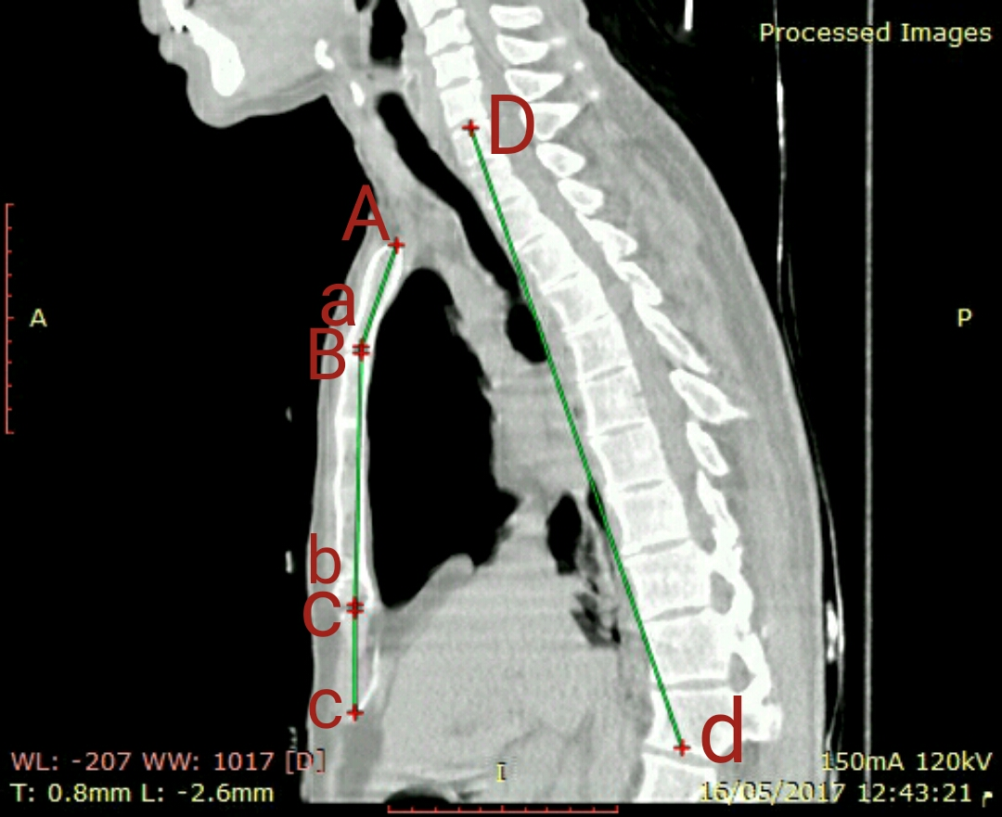

Fig.(3): A photograph of mid-sagittal CT scan of the chest showing the following parameters; the length of manubrium(Aa) is the distance measured from the centre of suprasternal notch to the centre of manubriosternal junction , the length of body(Bb) is the distance measured from the manubrio-sternal junction to the xiphi-sternal junction of the sternum, the length of xiphoid(Cc) is the distance measured from xiphi-sternal junction to the tip of the xiphoid process and the length of thoracic vertebrae (Dd) is the distance measured from upper border of first thoracic vertebrae to lower border of twelfth thoracic vertebrae.
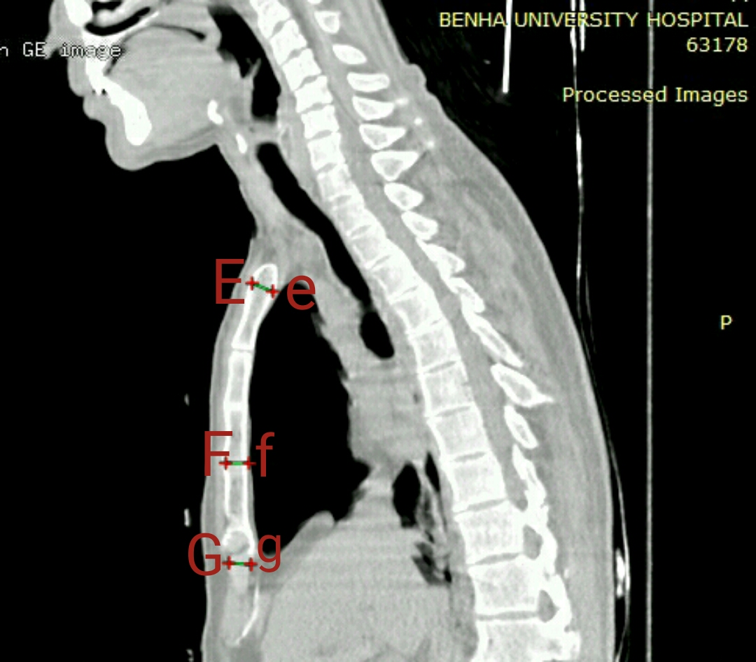
Fig. (4): A photograph of sagittal CT scan of the chest showing the following parameters; the thickness of manubrium(Ee), the thickness of body(Ff) and the thickness of xiphoid process(Gg).

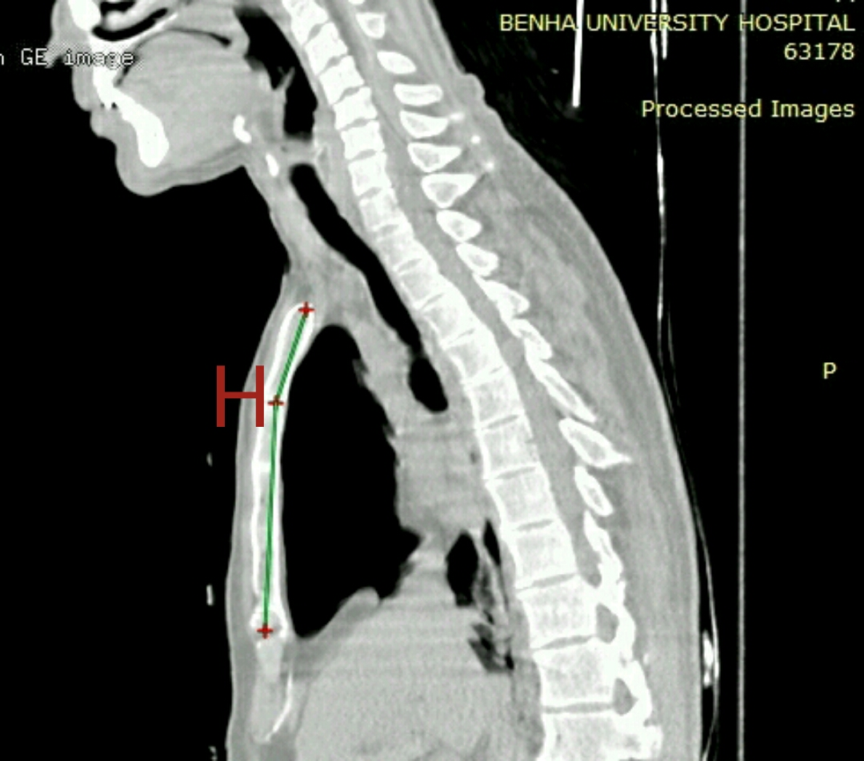
Fig. (5): A photograph of sagittal CT scan of the chest showing the sternal angle(H) formed between the manubrium and body of the sternum, the vertex of this angle lies at the manubriosternal joint.
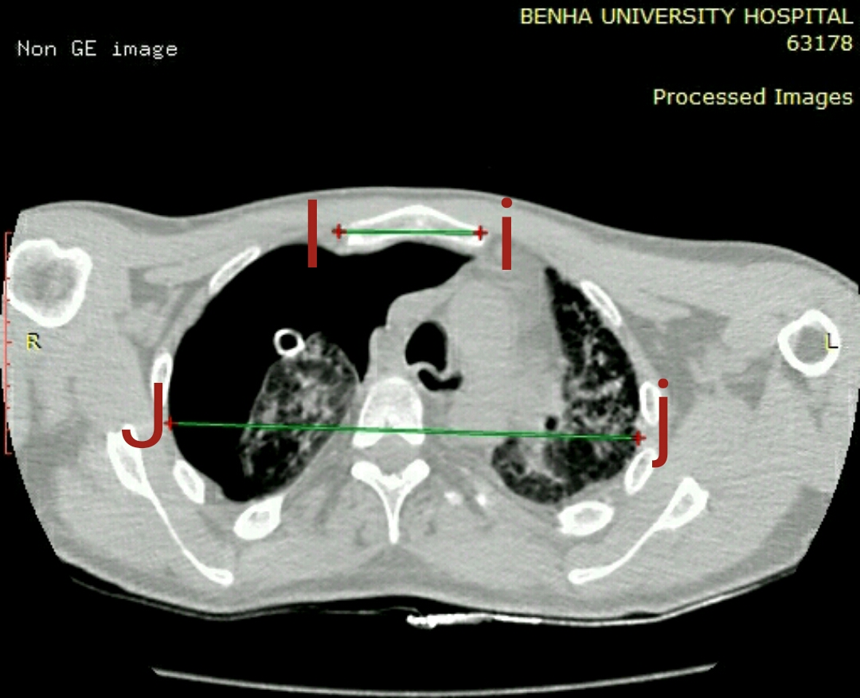
Fig.(6): A photography of axial CT scan of the chest showing the maximum breadth of manubrium (Ii) and breadth of the chest(Jj).
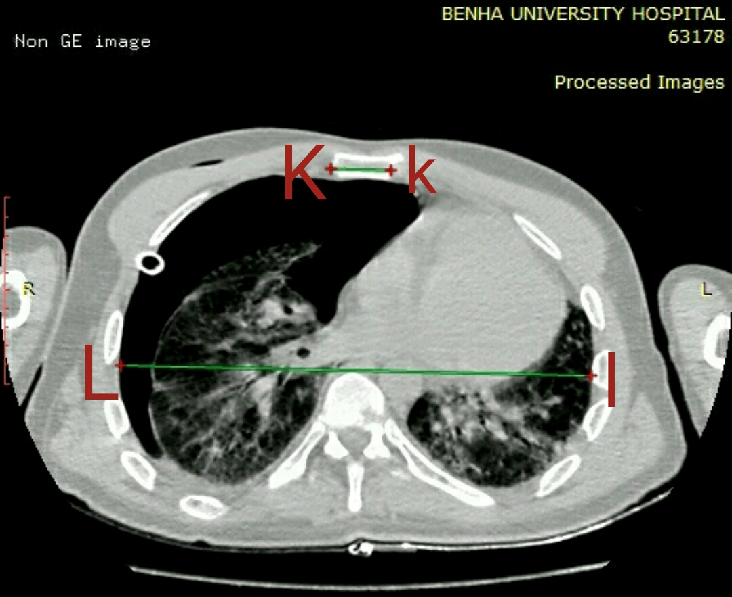
Fig.(7): A photography of axial CT scan of the chest showing the maximum breadth of body of the sternum (Kk) and breadth of the chest(Ll).
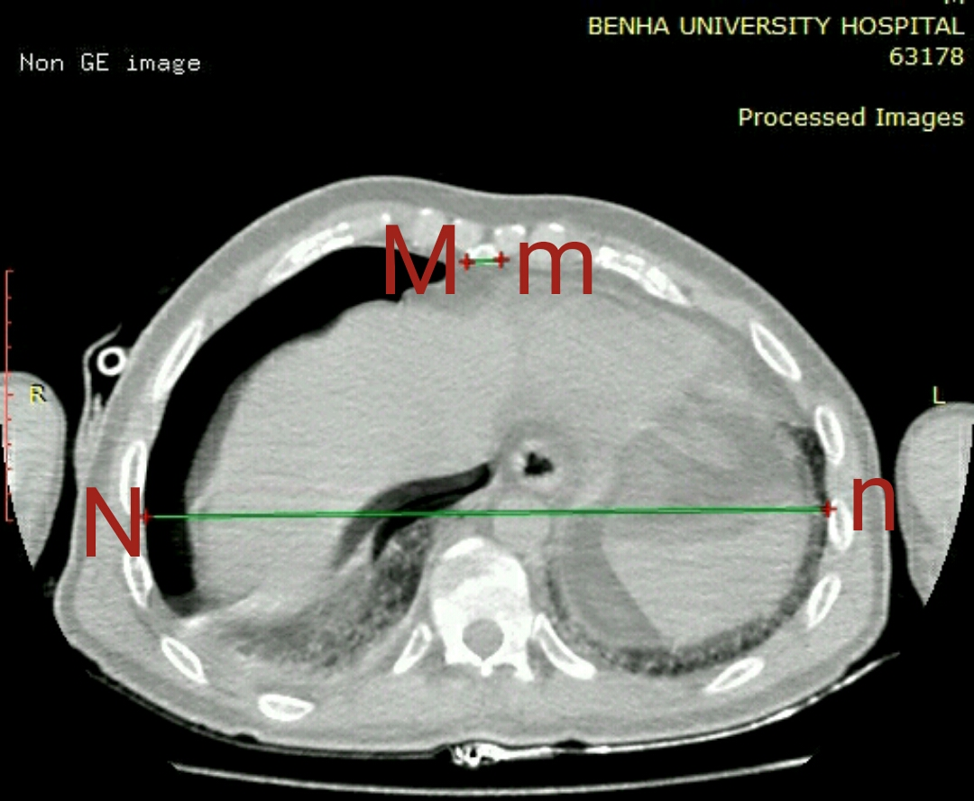
Fig.(8): A photography of axial CT scan of the chest showing the maximum breadth of xiphoid of the sternum (Mm) and breadth of the chest(Nn).
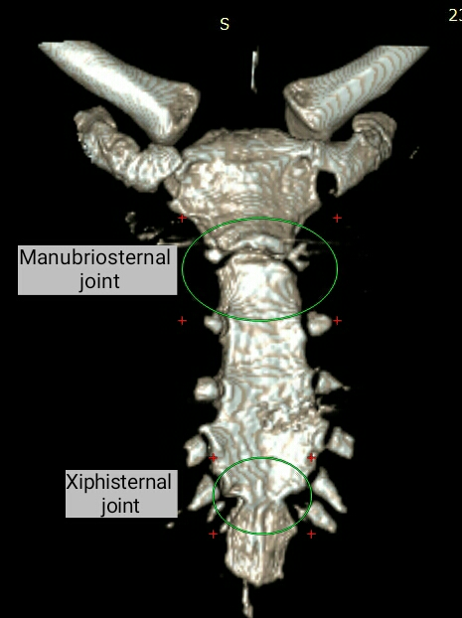
Fig. (9): 3D CT scan showing Manubriosternal and Xiphisternal junction.

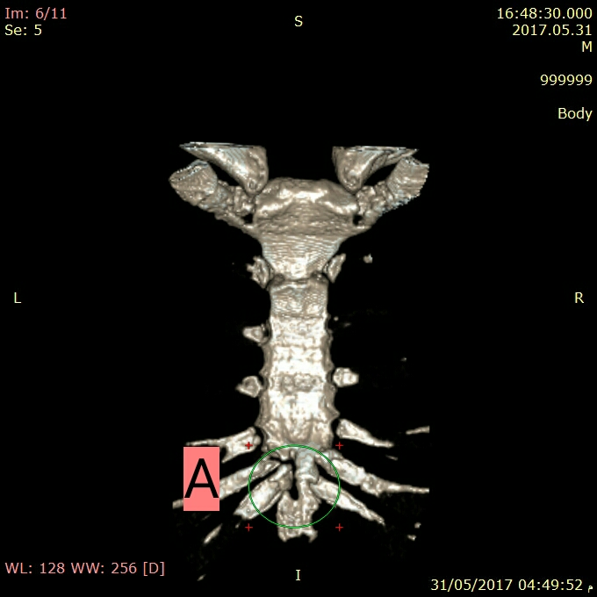
Fig. (10): 3D CT scan of sternum of male aged 48 years showing sternal foramen in the xiphoid process(A).

